Unit 2 Review Questions

1 | Select the computer science definition for: BRANCHING | - A name attached to data so your code can work with it.  - Reusable code with a name  - Change the program execution based on a condition  - A named value that doesn’t change during program execution.
2 | Select the computer science definition for: FUNCTION | - A name attached to data so your code can work with it.  - Reusable code with a name  - Change the program execution based on a condition  - A named value that doesn’t change during program execution.
3 | Select the computer science definition for: VARIABLE | - A name attached to data so your code can work with it  - Reusable code with a name  - Change the program execution based on a condition  - A named value that doesn’t change during program execution.
4 | Select the computer science definition for: CONSTANT | - A name attached to data so your code can work with it.  - Reusable code with a name  - A set of three values returned by the ranger sensors.  - A named value that doesn’t change during program execution
5 | Select the computer science definition of: MODULE | - A named value that doesn’t change during program execution.  - A name attached to data so your code can work with it.  - An external source of code that can be imported.  - A set of three values returned by the ranger sensors.
6 | Select the computer science definition of: TUPLE | - Changing the value with assignment, like adding 1.  - A name attached to data so your code can work with it.  - An external source of code that can be imported.  - A set of three values returned by the ranger sensors.
7 | Select the computer science definition of: UPDATING A VARIABLE | - Changing the value with assignment, like adding 1.  - A name attached to data so your code can work with it.  - An external source of code that can be imported.  - A set of three values returned by the ranger sensors.
8 | Select the computer science definition of: BLOCKING | - A function that prevents the next line of code from executing until it is completed.  - Interactively enter commands in the console and view output.  - An external source of code that can be imported.  - A function that returns immediately so the next line of code can execute.
9 | Select the computer science definition of: NON-BLOCKING | - A function that prevents the next line of code from executing until it is completed.  - Interactively enter commands in the console and view output.  - An external source of code that can be imported.  - A function that returns immediately so the next line of code can execute.
10 | Select the computer science definition of: REPL | - A function that prevents the next line of code from executing until it is completed.  - Interactively enter commands in the console and view output.  - An external source of code that can be imported.  - A function that returns immediately so the next line of code can execute.

Python Coding:

1 | What is this code an example of?  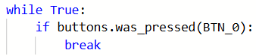 | - Iteration  - Variable  - Function  - Safety interlock
2 | What is this code an example of?  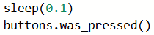 | - Bouncing a button  - Debouncing a button  - Creating a function  - Using a variable
3 | What line of code defines a function? | - define function_name:  - def function_name:  - def function_name():  - function_name()
4 | What line of code is a function call? | - function_name()  - function_name():  - function_name  - call function_name
5 | What line of code assigns a value to a variable? | - GREEN  - do_launch = False  - if buttons.was_pressed(BTN_1):  - for n in range(3):
6 | What does the variable do_launch keep track of?  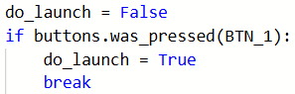 | - If the loop has finished  - If the loop has been broken  - If BTN_1 has been pressed  - If either button has been pressed
7 | Which CodeAIR sensor is used for tracking and holding position? | - Pressure sensor  - Laser rangers  - Optical flow sensor  - Light sensor
8 | What must be included in your code to call the button_arm() function | - def button_arm():  - from safety import *  - from codeair import *  - while True:
9 | What is a key component for keeping the drone flying at a desired altitude? | - Laser rangers  - Pressure sensor  - Optical flow sensor  - Light sensor
10 | What function reads the laser rangers? | - data(RANGERS)  - rangers.data()  - get_data(RANGERS)  - rangers.read()
11 | What line of code unpacks the tuple returned by get_data()? | - get_data.unpack()  - fwd, up, down = get_data()  - get_data() = fwd, up, down  - (fwd, up, down) = get_data()
12 | What is the result of the code?  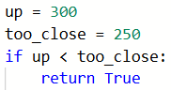 | - True is returned  - False is returned  - Nothing happens  - The program stops
13 | What is the result of the code?  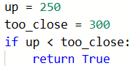 | - True is returned  - False is returned  - Nothing happens  - The program stops
14 | If fwd is always more than 300, what is the result of the code?  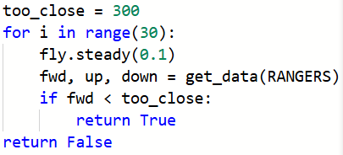 | - True is returned  - False is returned  - Nothing happens  - The program stops
15 | What code will cause a continuous speaker beep? | - speaker.beep(440)  - speaker.beep(440, 100)  - speaker.beep(440, 0)  - speaker.on()
16 | What will print after this code runs?  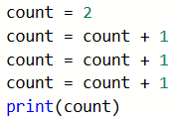 | - 2  - 1  - 5  - 3
17 | What will print after this code runs?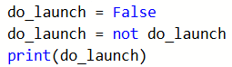 | - True  - False  - do_launch  - An error occurs
18 | Which function is non-blocking? | - fly.steady(seconds)  - fly.land()  - fly.start_forward()  - fly.forward(distance, velocity)
19 | What is the result of the code?  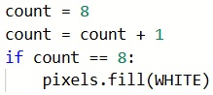 | - All pixels are turned WHITE  - Nothing happens  - All pixels are turned off  - An error occurs
20 | What function turns off all blue LEDs? | - leds.set_off()  - leds.set(0)  - leds.set(BLACK)  - leds.set_mask(0, 0)

